Create a react app for Student Management Portal named scorecalculatorapp and create a function component named “CalculateScore” which will accept Name, School, Total and goal in order to calculate the average score of a student and display the same.

1. Create a React project named “scorecalculatorapp” type the following command in terminal of Visual studio:



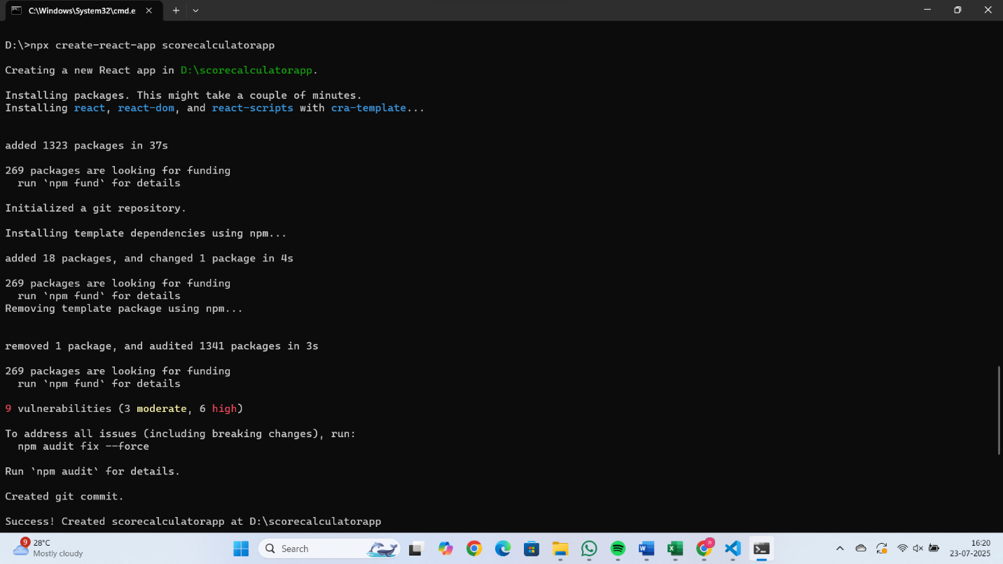

1. Create a new folder under Src folder with the name “Components”. Add a new file named “CalculateScore.js”
2. Type the following code in CalculateScore.js

import React from 'react';

import '../Stylesheets/mystyle.css';

function CalculateScore() {

  const name = "Divya Neelam";

  const school = "ABC Public School";

  const total = 450;

  const goal = 500;

  const average = (total / goal) \* 100;

  return (

    <div className="score-container">

      <h2>Score Calculator</h2>

      <p><strong>Name:</strong> {name}</p>

      <p><strong>School:</strong> {school}</p>

      <p><strong>Total Marks:</strong> {total}</p>

      <p><strong>Goal Marks:</strong> {goal}</p>

      <p className="highlight"><strong>Average Score:</strong> {average.toFixed(2)}%</p>

    </div>

  );

}

export default CalculateScore;

1. Create a Folder named Stylesheets and add a file named “mystyle.css” in order to add some styles to the components:

.score-container {

  border: 2px solid #333;

  border-radius: 10px;

  padding: 20px;

  width: 400px;

  margin: 50px auto;

  background-color: #f0f8ff;

  font-family: Arial, sans-serif;

}

.score-container h2 {

  color: #2c3e50;

  text-align: center;

}

.highlight {

  color: green;

  font-weight: bold;

}

1. edit the App.js to invoke the CalculateScore functional component as follows:

import React from 'react';

import CalculateScore from './Components/CalculateScore';

function App() {

  return (

    <div>

      <CalculateScore />

    </div>

  );

}

export default App;

1. In command Prompt, navigate into scorecalculatorapp and execute the code by typing the following command:



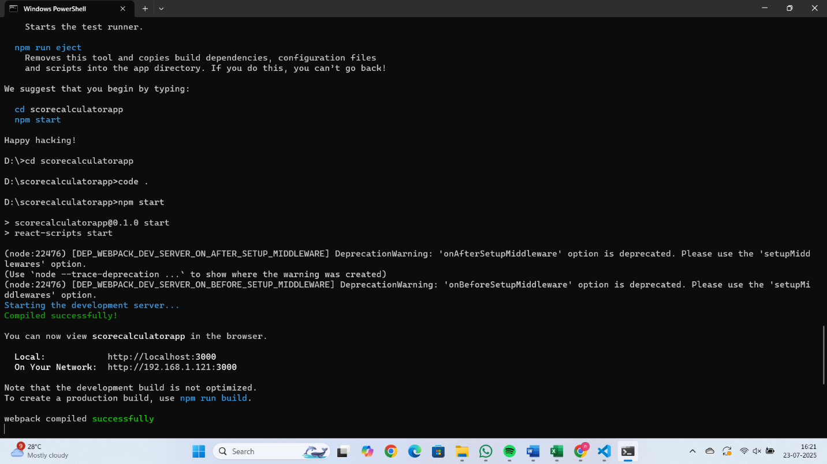

1. Open browser and type “localhost:3000” in the address bar:

